iCoLoc: An Interactive System for Mobile Location Data Mining via LLM-Guided Intent and Contrastive Preference Learning

Xijia Ye
Department of Intelligent Science and Technology
Guilin University Of Electronic Technology
Guilin, China
yexijia1124@163.com
line 1: 4th Given Name Surname
line 2: dept. name of organization
(of Affiliation)
line 3: name of organization
(of Affiliation)
line 4: City, Country
line 5: email address or ORCID
Xuguang Bao
Department of Intelligent Science and Technology
Guilin University Of Electronic Technology
Guilin, China
baoxuguang@guet.edu.cn
line 1: 5th Given Name Surname
line 2: dept. name of organization
(of Affiliation)
line 3: name of organization
(of Affiliation)
line 4: City, Country
line 5: email address or ORCID
Xinran Xu
Department of Intelligent Science and Technology
Guilin University Of Electronic Technology
Guilin, China
1178423998@qq.com
line 1: 6th Given Name Surname
line 2: dept. name of organization
(of Affiliation)
line 3: name of organization
(of Affiliation)
line 4: City, Country
line 5: email address or ORCID

Abstract—Traditional interactive pattern mining often requires users to possess specialized knowledge. Users must understand which patterns are relevant to their areas of interest, thereby selecting their field of interest at the outset.,in addition to this,Many traditional interactive systems have relatively fixed settings for mining-related parameters,which leaves a large number of patterns that users are not interested in, making it difficult for users to filter through the multitude of patterns,and user needs frequently change, yet traditional interactive systems cannot self-update or iterate to learn patterns users like or dislike, which to some extent increases the burden on users.Therefore,An Intelligent Interactive Co-location Mining System(iCoLoc) address this shortcoming through LLM and contrastive preference learning，iCoLoc will no longer needs users to possess a certain knowledge base,instead,users will be required simple nature query，The LLM will automatically parse user intent for similarity matching and recommend highly relevant patterns.It also retains the functionality for users to manually filter patterns of interest or disinterest, which are then used for model training.This demonstration illustrates how iCoLoc comprehends user intent and significantly enhances the efficiency of spatial pattern mining.
Keywords—Interactiven Pattern Mining, LLM contrastive preference learning

Introduction
Traditional spatial co-location pattern mining aims to discover frequently co-occurring feature sets from geographic data, such as nearby facilities or points of interest. Early studies defined measurement and mining strategies for co-location patterns using indicators such as the participation index and systematically categorized various algorithms, including frequent itemset-based, join-less, and graph-based approaches [1]. However, these methods mainly focus on spatial neighborhood relationships while ignoring instance-level access behaviors and user interests, which often leads to the generation of a large number of irrelevant patterns and imposes a heavy filtering burden on users.
In recent years, many improvements have been proposed, such as mining high-access co-location patterns by incorporating visitation information to enhance semantic value [2], and adopting graph-based methods to improve neighborhood modeling capability [3]. To address the problem of user preference expression and pattern selection, some interactive approaches have introd uced user involvement to better align mining results with practical needs [4]. Meanwhile, systematic studies have explored preference-aware co-location mining frameworks to provide theoretical support for personalized filtering and pattern compression [5].These studies collectively highlight the importance of incorporating preferences, constraints, and learning strategies into spatial co-location mining. Building upon this trend, iCoLoc leverages artificial intelligence to perform fuzzy query understanding, user vector construction, and dynamic optimization through contrastive learning, thereby improving the efficiency of spatial knowledge acquisition.
The goal of iCoLoc is to bridge the gap between users and professional spatial data mining expertise through AI, enhancing the efficiency and utilization of spatial.

System Overview
The framework is illustrated in Fig. 1 and consists of sev-en steps, as follows:
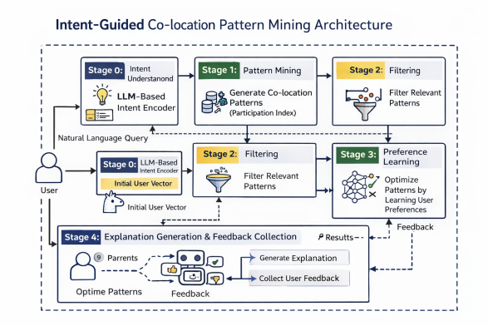
Fig.1: The system Architecture.
- System initialization; user inputs natural language for queries.
- The LLM extracts features from the user's natural language and infers relevant patterns to form the user's vector.
- Pattern Mining: Identifying High-Frequency Patterns
- Reorder based on similarity between patterns and user vectors
- Display the sorted patterns and generate result interpretations.
- Users select patterns, choosing those they are interested in and those they are not interested in.
- Feedback results are used to train the contrastive learning model and update user vectors.

DEMONSTRATION
The core of iCoLoc lies in bridging the gap between ordinary users and professional spatial data mining through LLM technology. By leveraging LLM to discern user intent, it reduces the cost of data mining for users. Furthermore, users can provide feedback within the results—selecting patterns of interest and those not—which in turn guides the model in learning preferences. This process refines user vectors to better align with individual preferences.

Fig.2: training part of iCoLoc system
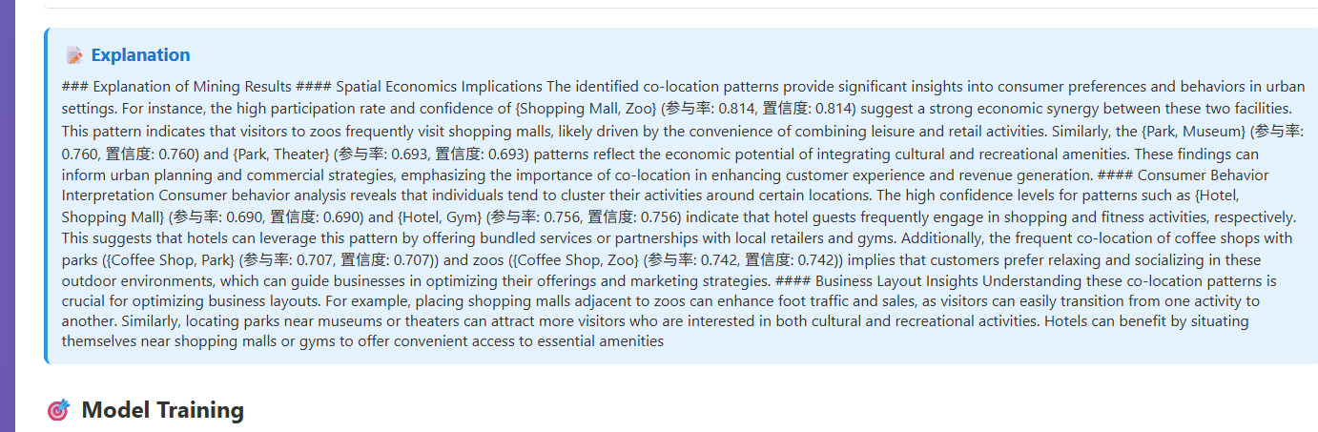
Fig.3: explanation part of iCoLoc system
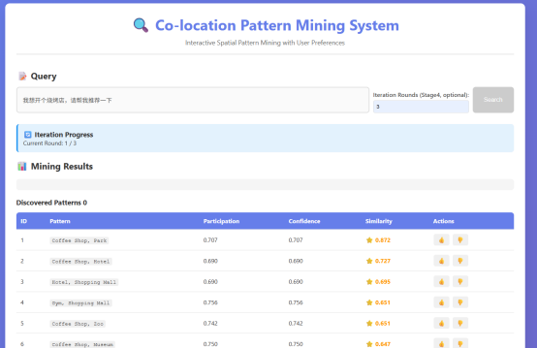
Fig.4: results display part of iCoLoc system
Fig.2 Figure 2 displays the training visualization. Users can click the manual training button to observe how the learning model iteratively refines user vectors through triplet loss learning based on user feedback, progressively aligning them with actual user intent. Alternatively, clicking the training history button reveals the loss decline trajectory, with this line chart illustrating the model's learning process.
Fig.3 Figure 3 illustrates the LLM's interpretation of pattern mining results. Through interactive processes, the LLM explains outcomes in response to user needs. This feature primarily serves to explain pattern mining results to users, providing reasonable explanations tailored to their preferences and query content.
Fig.4 Figure 4 displays the pattern recommendation results, showing each pattern's support, confidence, and similarity to the user vector. Users can select their preferred patterns by clicking the thumbs-up or thumbs-down buttons on the far right. After users indicate liked or disliked patterns, the system uses these selections as comparative learning data to train the model and further refine the user vector. This ensures user engagement during interaction, enabling the spatial data mining process to better uncover personalized patterns for each user.
Through this demonstration, we showcased how iCoLoc progresses from handling users' fuzzy queries to uncovering personalized patterns. By integrating LLM with contrastive learning, our system will more efficiently bridge the gap between general users and specialized knowledge. It learns user preferences, refines the construction of user vectors, filters out patterns that better align with user needs, and finally explains the connection between the uncovered patterns and user preferences.
We evaluate the effectiveness of iCoLoc against conventional methods in terms of accuracy. We compare iCoLoc with a baseline method and with the personalized region-of-interest recommendation approach proposed in 2025 [6]. The results are shown in the figure above. As can be seen, for the task of mining user-preferred patterns, iCoLoc consistently achieves equal or higher accuracy than the conventional methods, which indicates that the method is effective at capturing users’ true preferences.
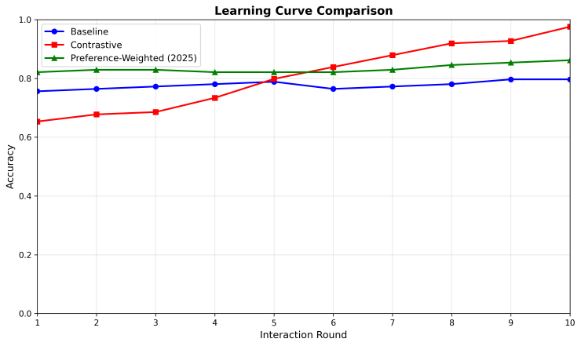Fig.4: efficiency evaluation result

Conclusion
In this demonstration, we present iCoLoc, a system that combines LLM with contra-stive learning to rapidly learn user characteristics, thereby swiftly distinguishing patterns of interest from disinterest. Unlike traditional discovery systems, it requires no prior user knowledge. Users only need to perform simple fuzzy queries and manually provide feedback on liked/disliked patterns. The system then uses LLM to make pattern preference decisions for users, initializing user vectors. It continuously refines these vectors through learning user preferences based on pattern engagement, ensuring subsequent filtered patterns align with user interests.

Acknowledgment
This work was supported in part by the National Natural Science Foundation of China under grants No. U22A2099, No. U1811264, No. U1711263, No. 61966009, No. 62006057, and the Guangxi Natural Science Foundation under grant No.2025GXNSFAA069551.

References
- A. Zala, J. Patel, and D. Patel, "A survey on spatial co-location pattern mining," International Journal of Computer Applications, vol. 96, no. 19, pp. 1–7, 2014.
- J. Wang, Y. Liu, X. Zhang, et al., "Mining high-access spatial co-location patterns from location-based service data," Knowledge-Based Systems, vol. 263, p. 110331, 2023.
- L. Wang, P. Yang, L. Zhou, et al., "Graph-based spatial co-location pattern mining with neighborhood modeling," Information Sciences, vol. 666, p. 120407, 2024.
- X. Bao, T. Gu, L. Chang, et al., "Knowledge-based interactive postmining of user preferred co-location patterns using ontologies," IEEE Transactions on Cybernetics, vol. 52, no. 9, pp. 9467–9480, 2021.
- L. Wang, Y. Fang, and L. Zhou, "Preference-aware spatial co-location pattern mining: A framework and applications," Expert Systems with Applications, vol. 198, p. 116821, 2022.
- Q. Tang, S. Xu, Y. Wang, S. Liu, Z. Wang, and H. Hua, "Personalized region of interest recommendation through adaptive fusion of multi-dimensional user preferences," Journal of Big Data, vol. 12, p. 224, 2025

